Project Report Of Vehicle Management System

1. Introduction
   1. Overview

The main objective of the project on vehicle management sytem is to manage the details of Vehicle,Driver, Insurance,Maintanance, Fuel. It manages all the information of the Vehicle, Vehicle Type, Fuel. The project is totally built at administrative end and thus only the administrator is guaranteed the access. The purpose of the project is to build an application program to reduce the manual work for managing the Vehicle ,Driver,Vehicle type, Insurance. It tracks all the details about the insurance, Maintanance, fuel.

* 1. Purpose

Vehicle management an application where a customer Details are stored in order to choose cars,bikes and commercial vehiclesfor travel with in the city . The data which is stored here is further used to remind them if any offers are provided during the seasons and any updates regarding vehicles are sent to them in the form of messages and mails.

2 Problem Definition & Design Thinking

2.1 Empathy Map 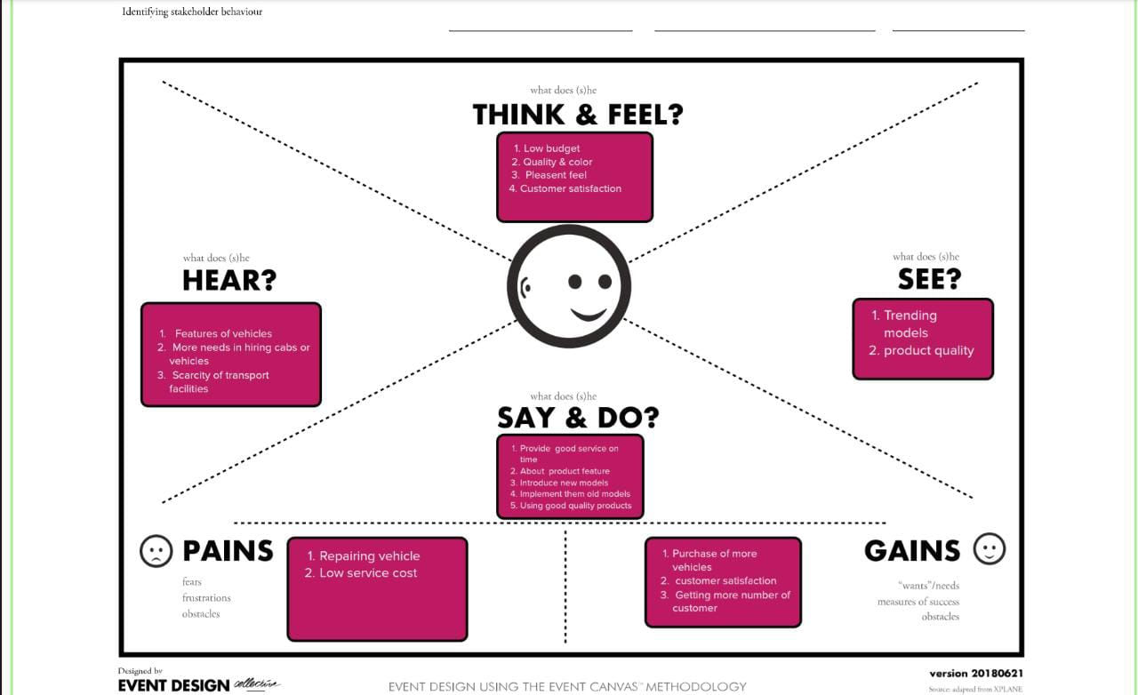

2. 2 ideation & Brainstorming map

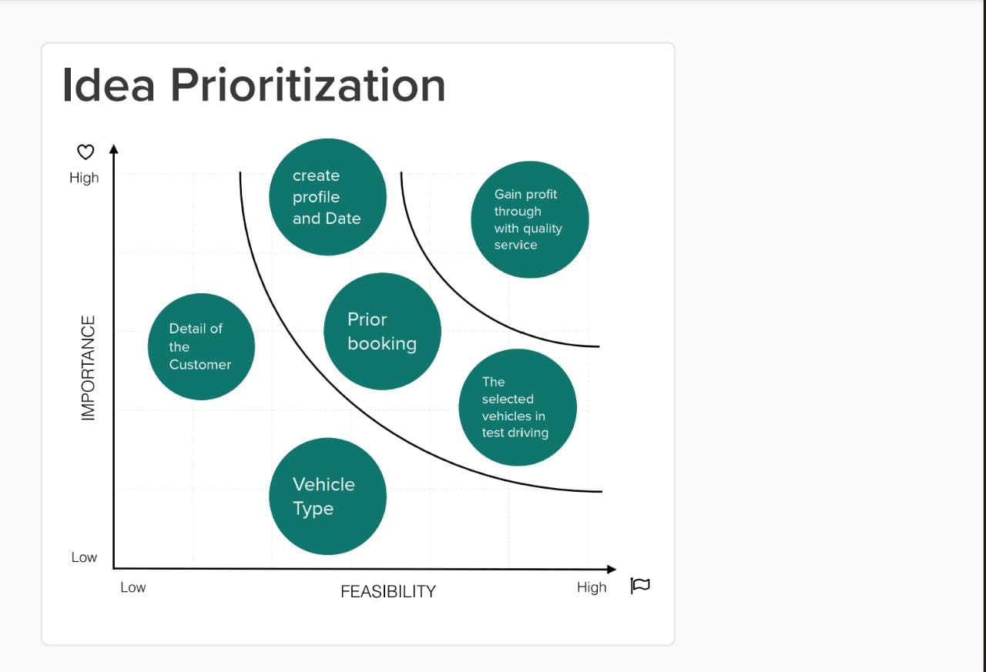

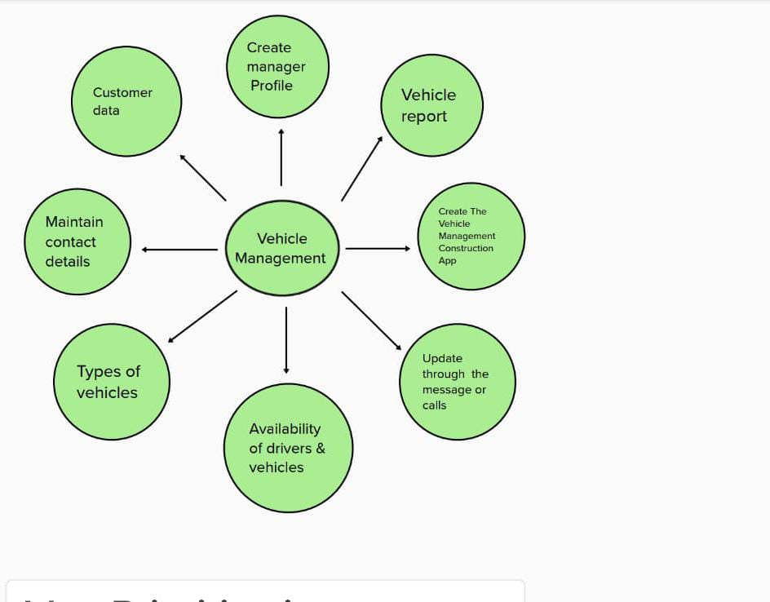

3 . RESULT

3.1 Data model

Object Name : Vehicle

|  |  |  |
| --- | --- | --- |
| S.No | Field Names | Data Typ |
| 1 | Customer Name | Text |
| 2 | Customer Mobile No | Number |
| 3 | Vehicle Type i)2 wheeler ii)4 wheeler | Picklist |
|
|
| 4 | 2WHEELERS i) HERO ii)HONDA iii)BAJAJ iv)ROYAL ENFIELD v)TVS vi)KINETIC vii)OLA viii)JAWA ix)SD x)BATTERY | Picklist |
|
|
|
|
|
|
|
|
|
|
| 5 | 4WHEELERS i) RENAULT ii)SKODA iii) HONDA iv)HYUNDAI v)SUZUKI vi)MAHINDRA vii)VOLKSWAGEN viii)BENZ ix)AUDI x)VOLVO | Picklist |
|
|
|
|
|
|
|
|
|
|
| 6 | Vehicle Name | Text |
| 7 | Vehicle No | Text |
| 8 | Chassic No | Text |
| 9 | Colour | Text |
| 10 | Body Type | Text |
| 11 | Vehicle Includes i)Fire Extenuation ii)First Aid Kit iii)Multi Charger kit iv)Stepney v)Stereo vi)Tool Kit vii)Tracking Device viii)Tyre Jack | Multi Picklist |
|
|
|
|
|
|
|
|
| 12 | Condition i)Good ii)Medium iii)Least | Picklist |
|
|
|
| 13 | Mileage | Text |
| 14 | Seats | Number |
| 15 | Start Date | Date/Time |
| 16 | End Date | Date/Time |
| 17 | Opportunity | Lookup(opportunities) |

Object Name : Driver

|  |  |  |
| --- | --- | --- |
| S No | Field | Data Type |
| 1 | Driver Name | Text |
| 2 | Licence No | Text |
| 3 | Mobile No | Number |
| 4 | Fair per hour | Text |
| 5 | Vehicle | Lookup( Vehicle) |

3.2 Activity & Screen shot

3.2.1 Login to salesforce account

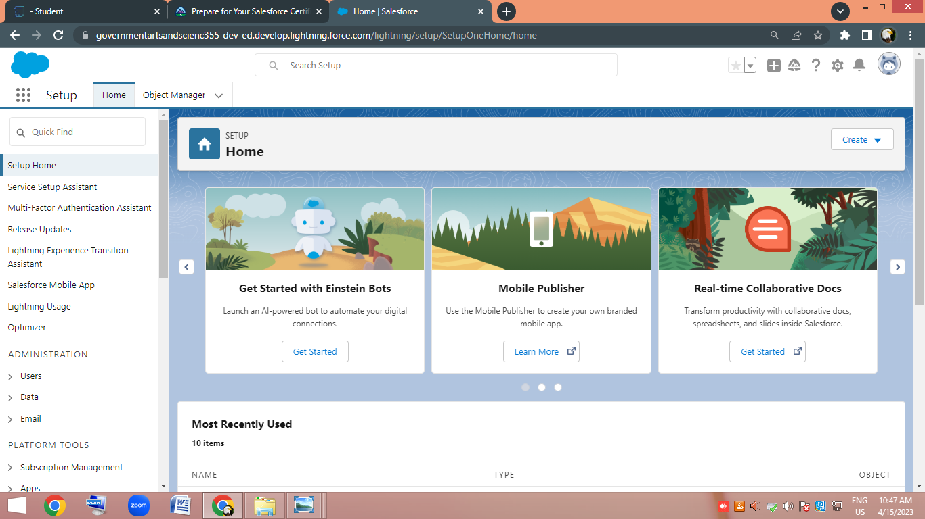

3.2.2 Creating object

Vehicle object

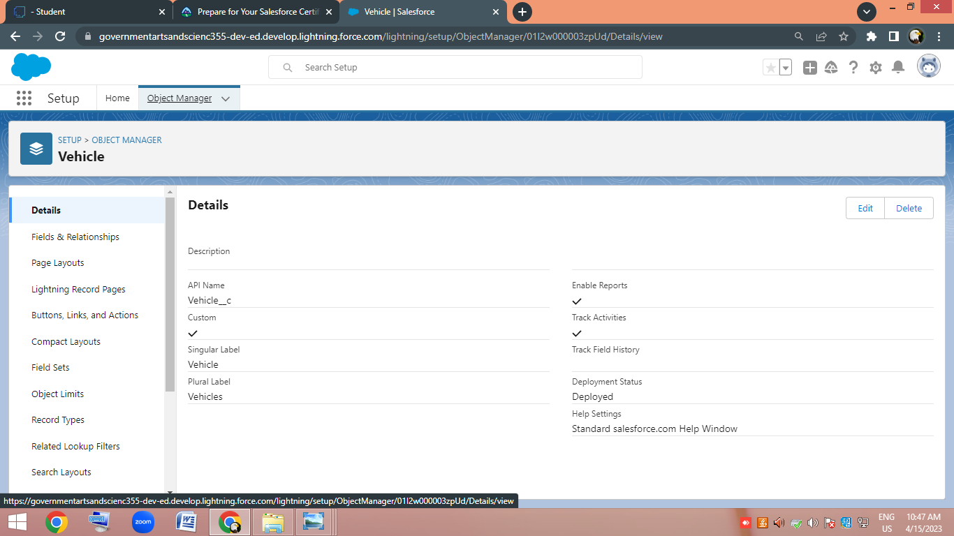

Driver object

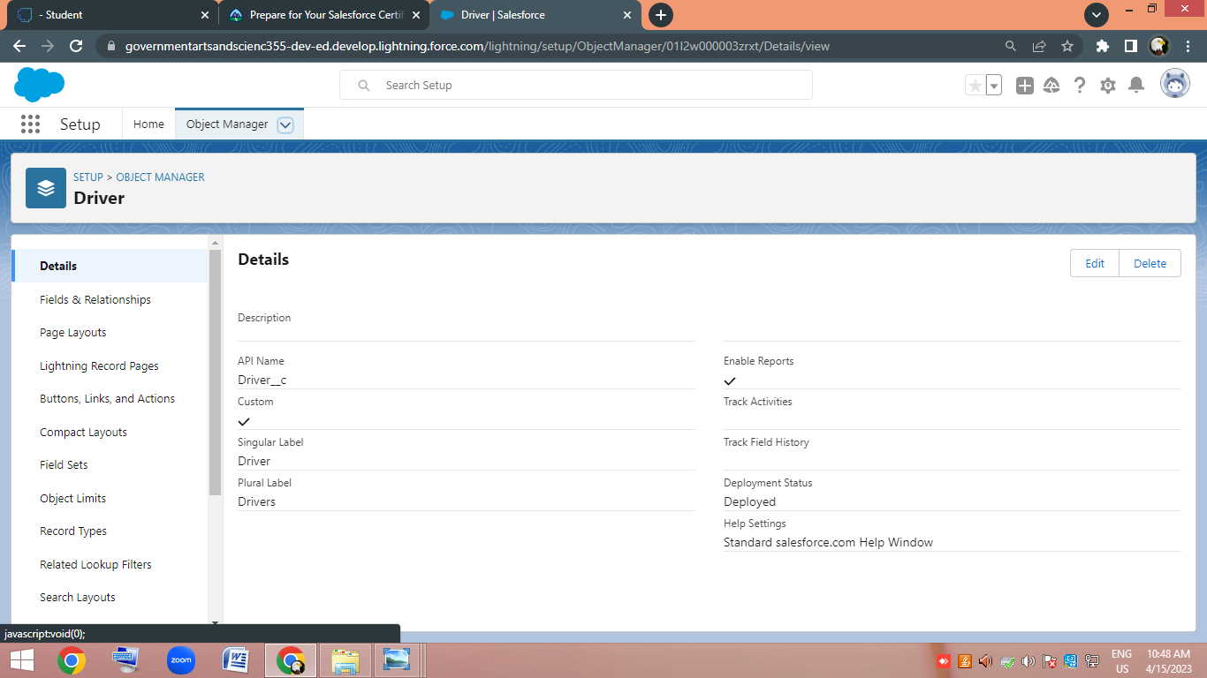

3.2.3 Fields and Relationship

Fields in vehicle objet

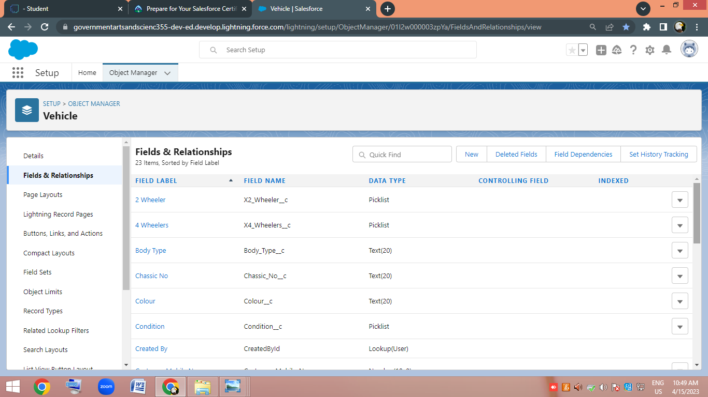

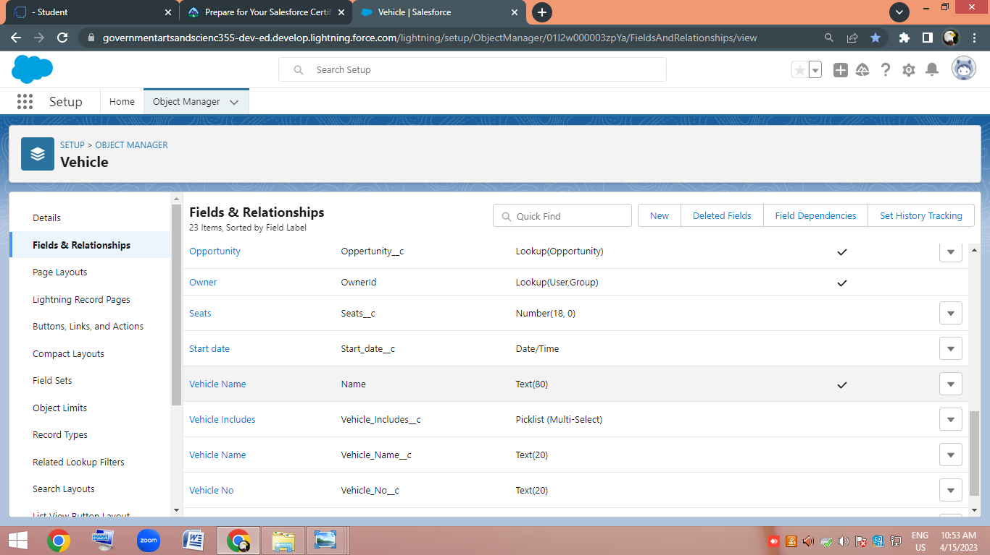

Fields in Driver object

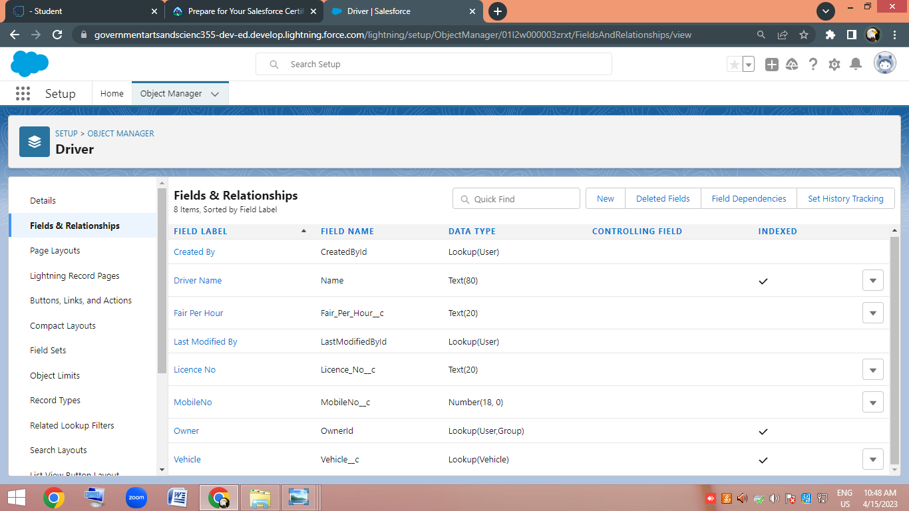

3.2.4 Lightning App

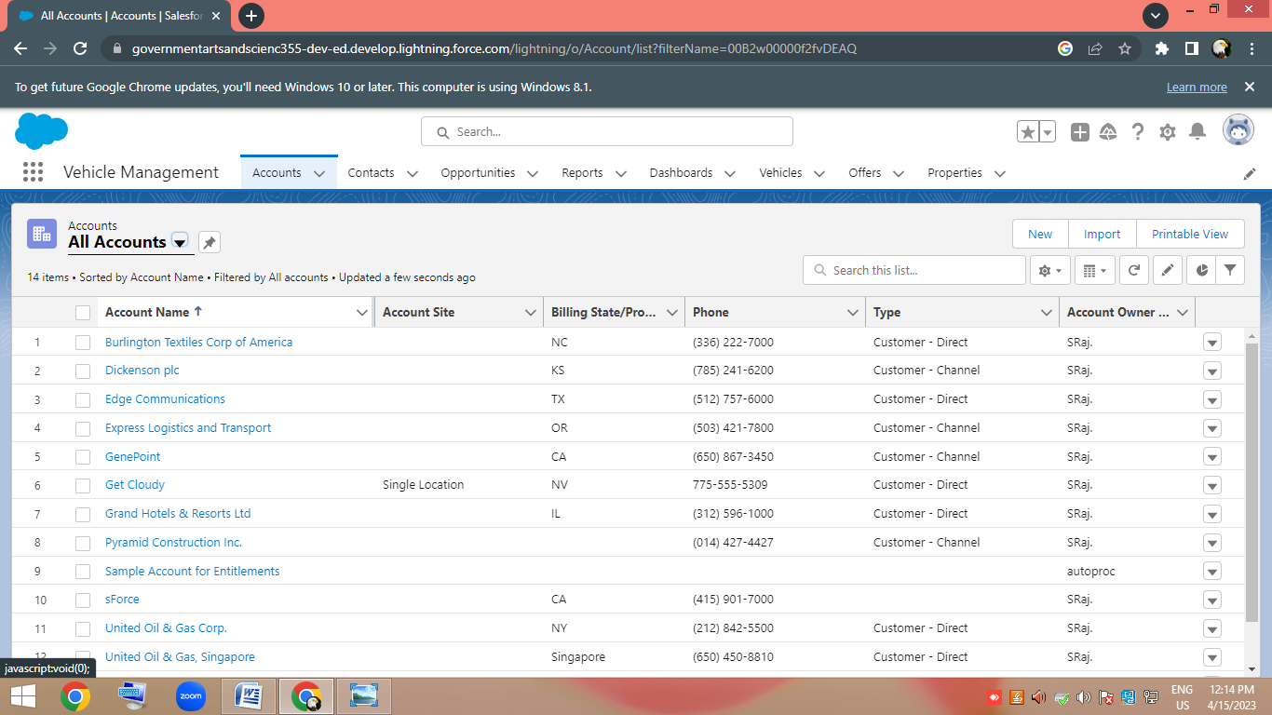

3.2.5 Profiles

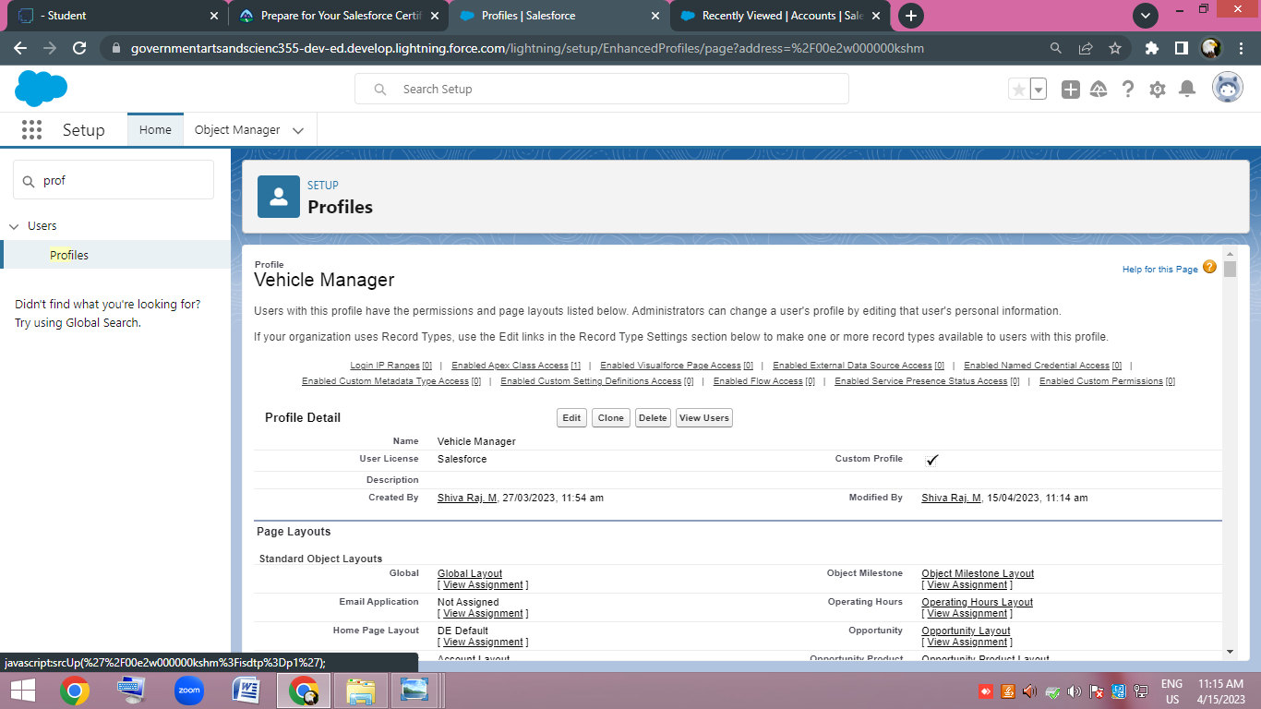

3.2.6 Users

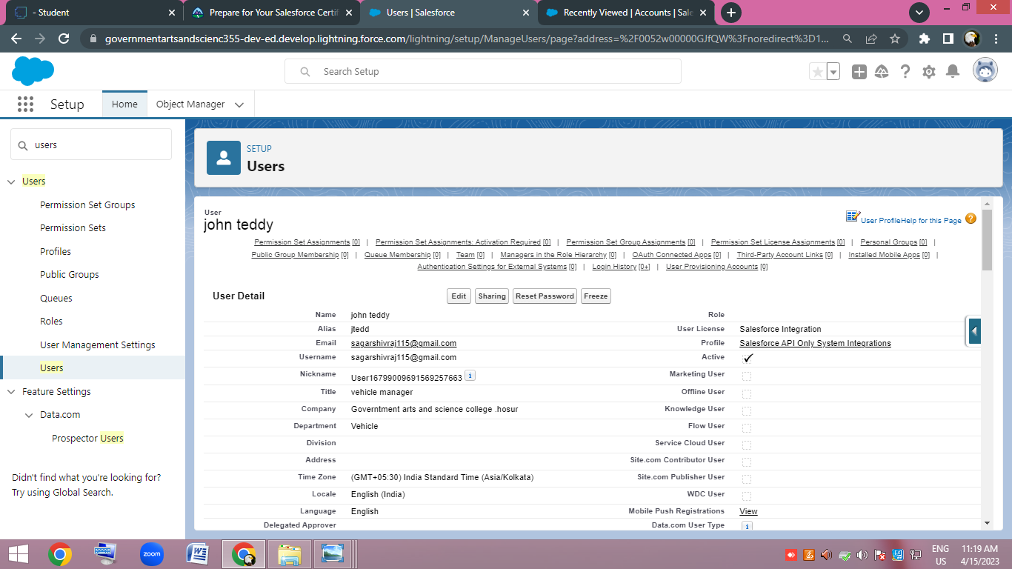

3.2.7 Reports & Dashboard

Reports

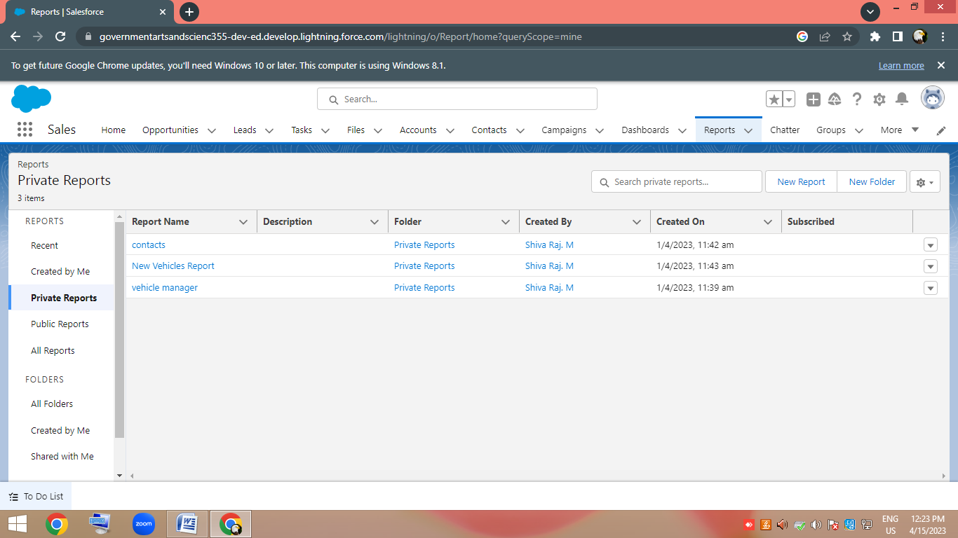

Dashboards

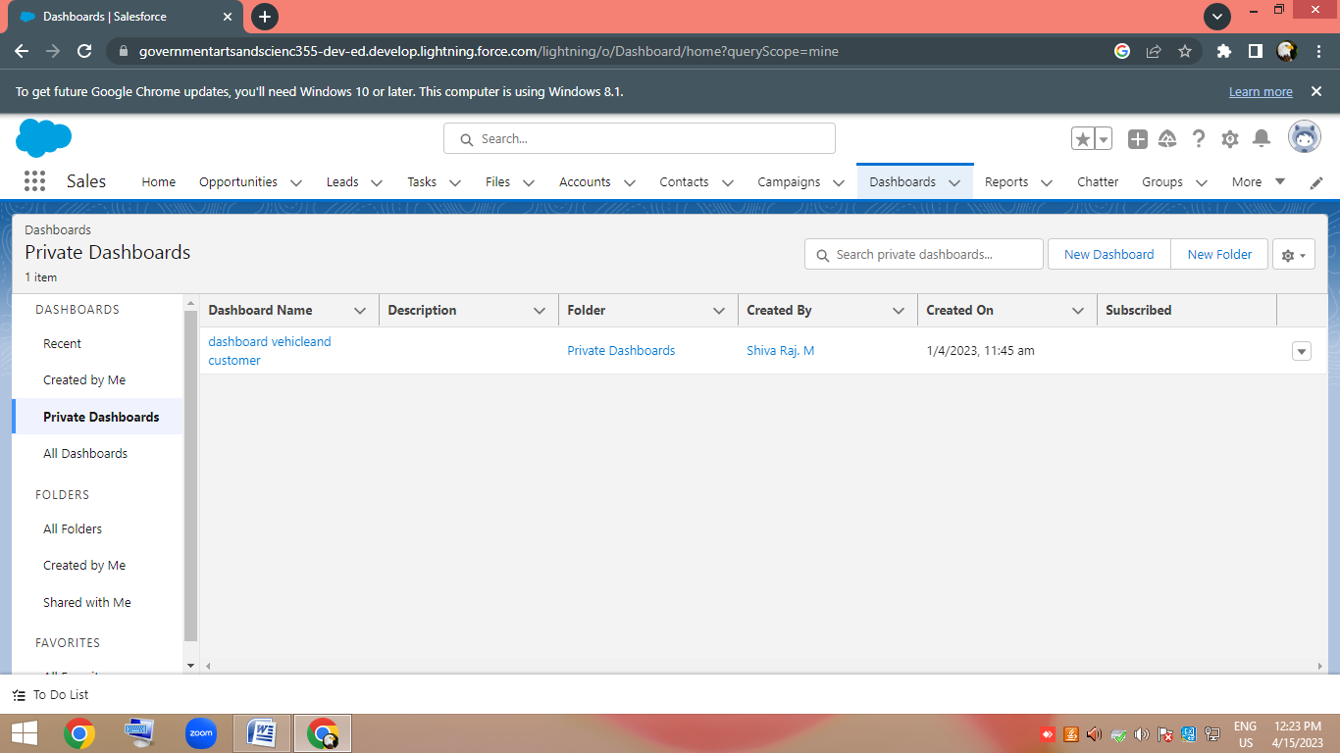

4. Trailhead profile public URL

Team Lead : <http://trailblazer.me/id/aamrutha7>

Team Members 1 : <https://trailblazer.me/id/uzemdrzq>

Team Member 2 : <https://trailblazer.me/id/sshivam39>

Team Member 3 : <https://trailblazer.me/id/llathikas>

5. Advantages & Disadvantages

Advantages

Improve fleet safety and working conditions

1. Improve the behaviour and performance of drivers and beat unsafe driving
2. Leverage driver retention
3. Track vehicles assets of professionals equipment ( even traills and containers)
4. Schedule routine maintenance
5. Manage fuel efficiency
6. Schedule shift and work hours
7. Keep track of malfunctions.

Disadvantages

1. It is difficult to track the occupancy
2. More manual hours need to generate required reports
3. Initial maintenance cost is high
4. Difficulty for communications.

6. Application

* As part of vehicle booking ,information are collected from the customer
* When the vehicles is returned, following details are collected

1. Damages if any
2. Miles/kilometre run by the vehicles
3. Fuel level.

* Provide rental booking receipt to customer by emails.

7. CONCLUSION

The vehicle management system proposed to make easy process of managing vehicle with the objective to replace current approach.

8. FUTURE SCOPE

* Connected cars will avoid traffic,find parking,speak other cars.
* Real time traffic updates will suggest route changes.